**Example 5**

You need to plot shear force and bending moment diagrams for the beams below. In addition, you need to find maximum values of deflections and stresses for each beam.

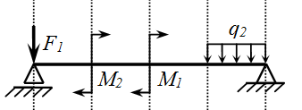

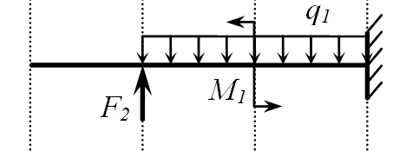

Accept the following values of constants in calculations:



A cross-section of all beams is presented in figure 1. The height of the cross-section is 0,08 m, the width is 0,04 m. The thickness of the beam is 0,004 m.:

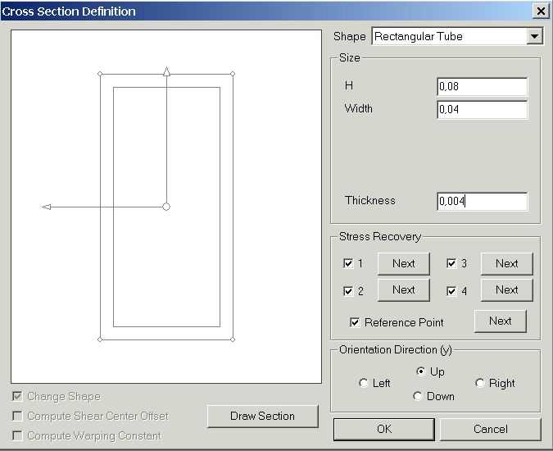

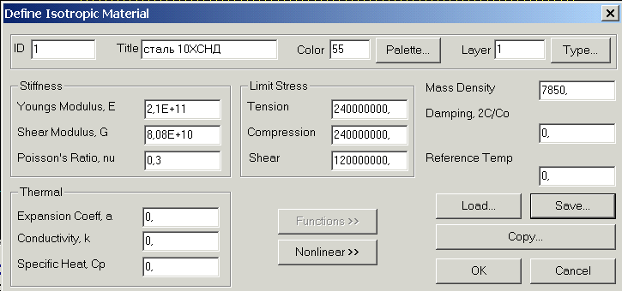

Beam 1



1. Create the cross-section sketch:

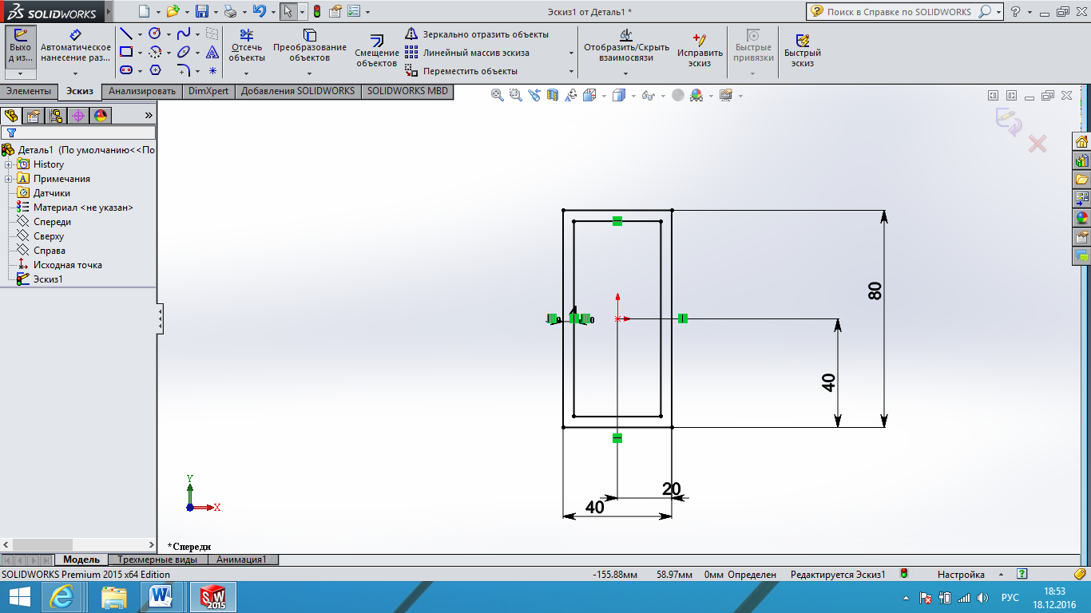

1. Extrude the sketch

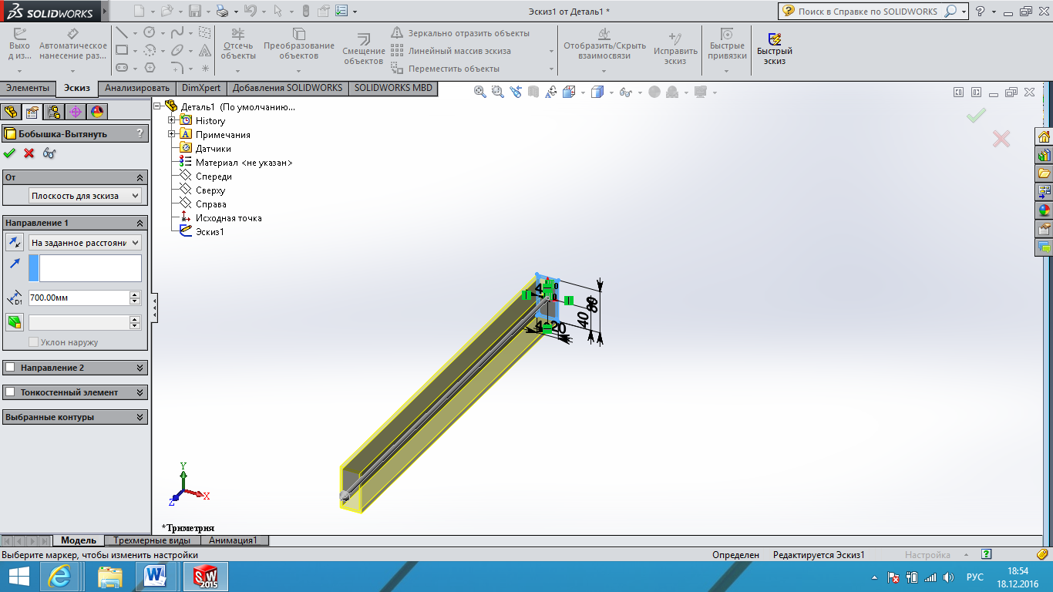

1. Extrude three more times to obtain the following geometry:

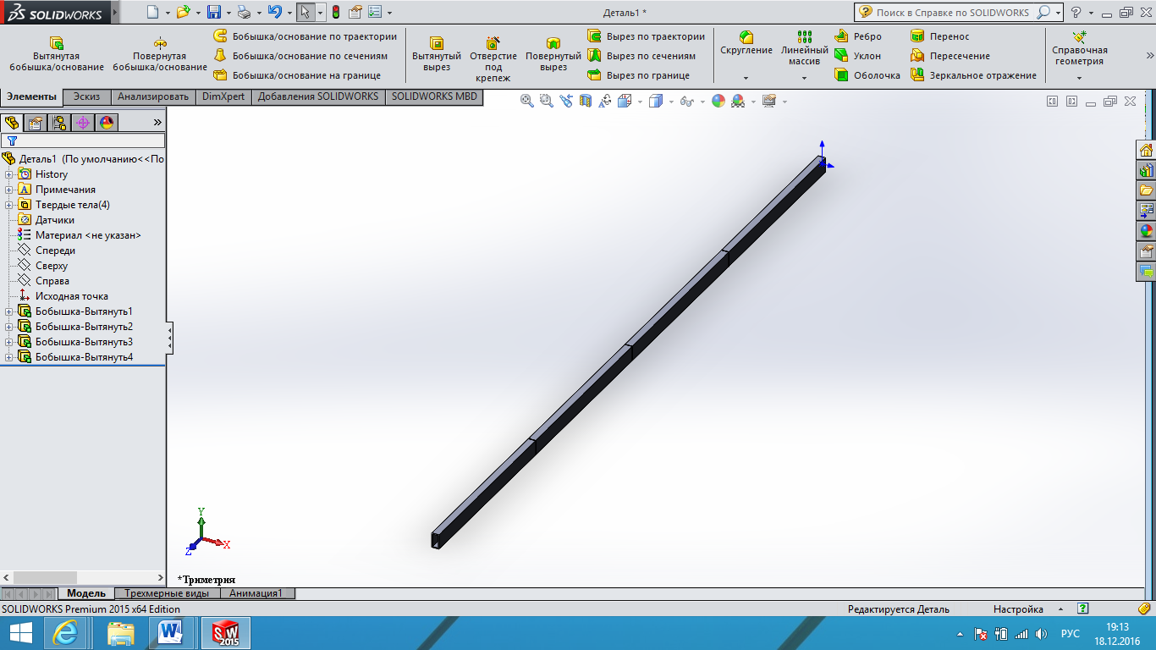

1. Open the Simulation tab and create new Static Analysis
2. To assign material we go to the corresponding tab [clip_image008](http://cadregion.ru/wp-content/uploads/2011/07/clip_image0081.gif) and select mechanical properties of ***STEEL***.
3. Select all created solids and press RMB on it to consider the bodies as beams. After that the icon must change to [Описание: clip_image007](http://cadregion.ru/wp-content/uploads/2011/07/clip_image007.gif)

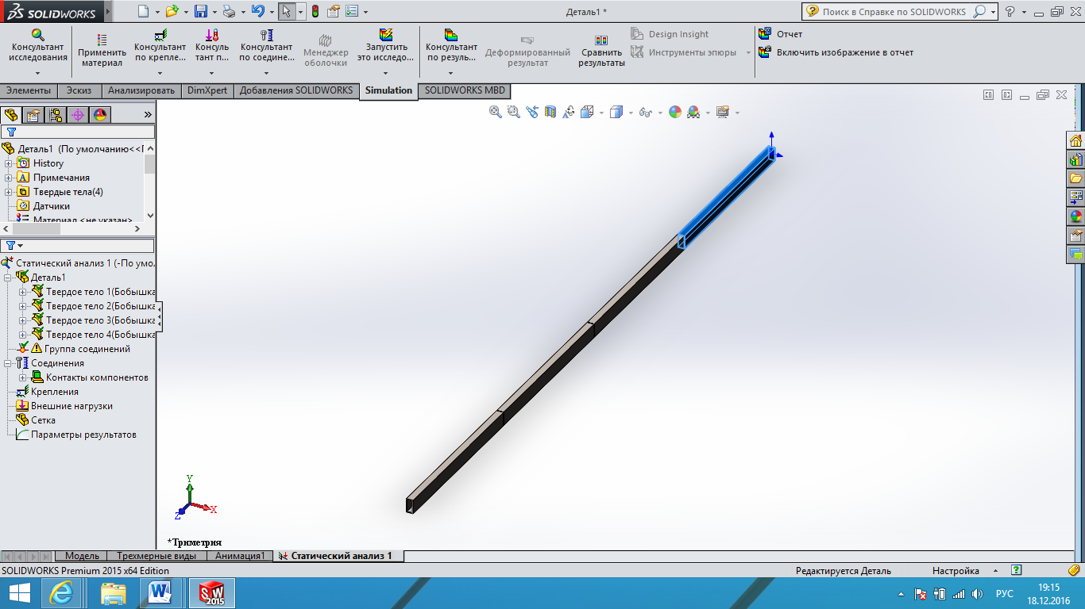

1. Press RMB on connection group [Описание: clip_image004](http://cadregion.ru/wp-content/uploads/2011/07/clip_image0041.gif) and choose edit. After than you need to select all beams and press ***Calculate*** button. The results should appear as shown in figure below.

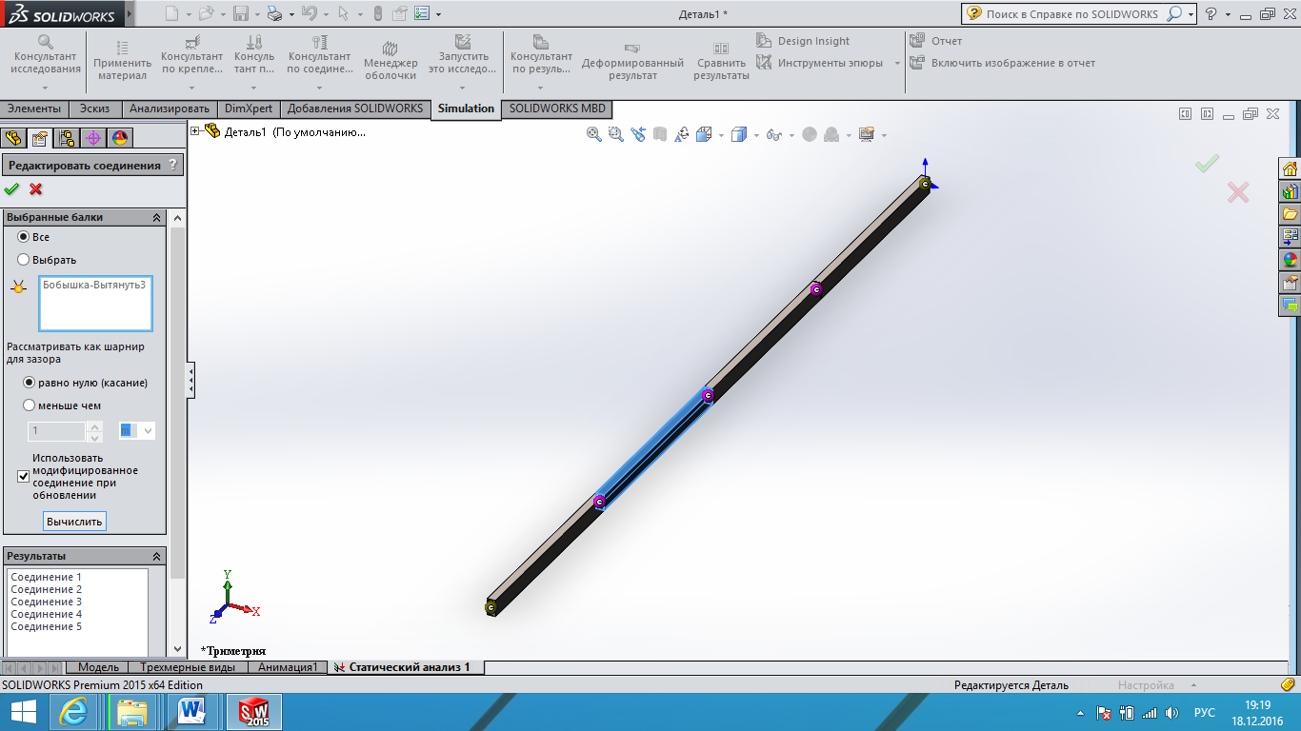

1. To apply constraints [Описание: clip_image010](http://cadregion.ru/wp-content/uploads/2011/07/clip_image0101.gif) you should chose fixed geometry option.

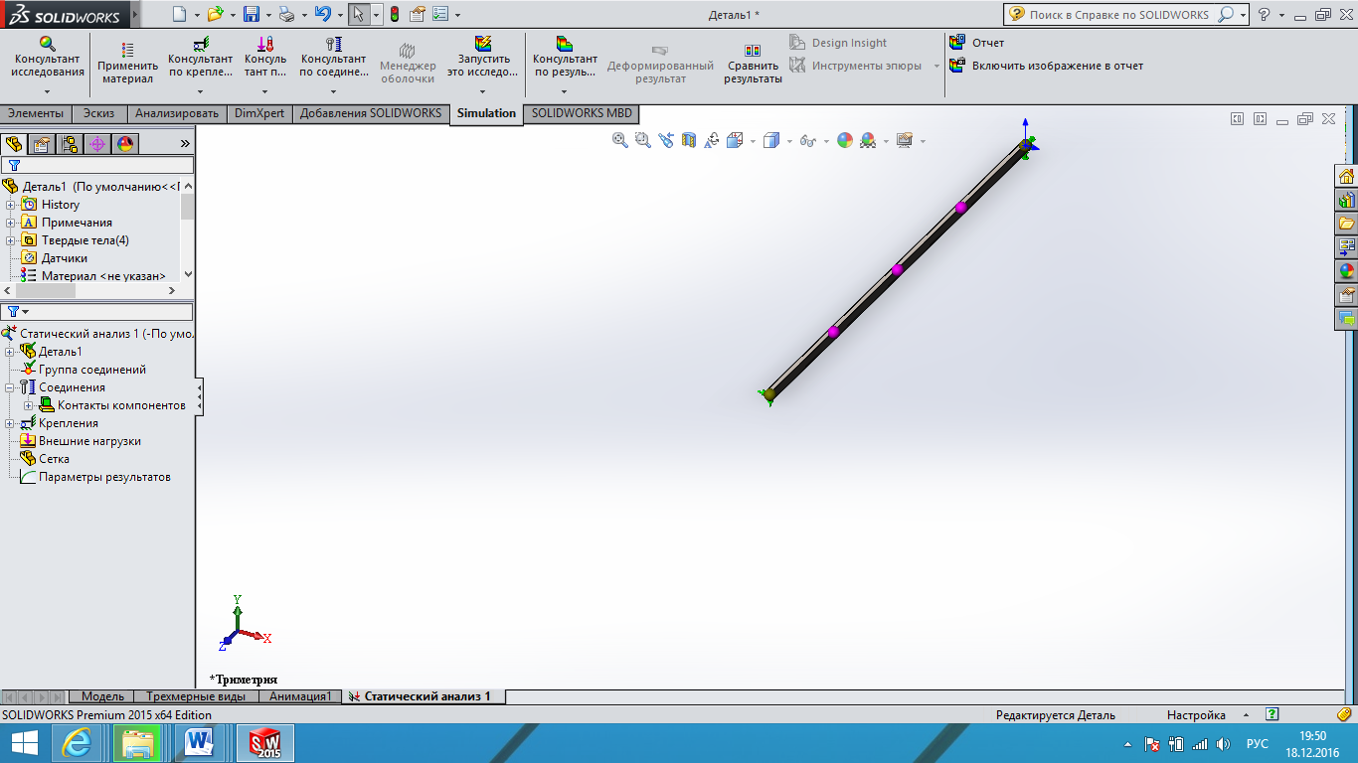

1. Next figure shows you the process of applying constraints in more details.

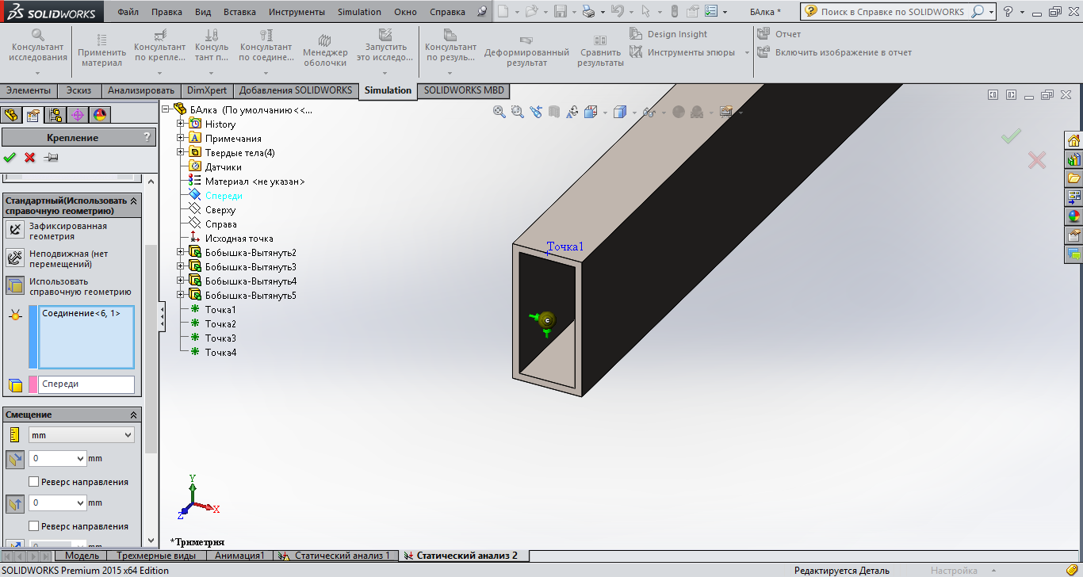

1. Next you apply forces as follows:

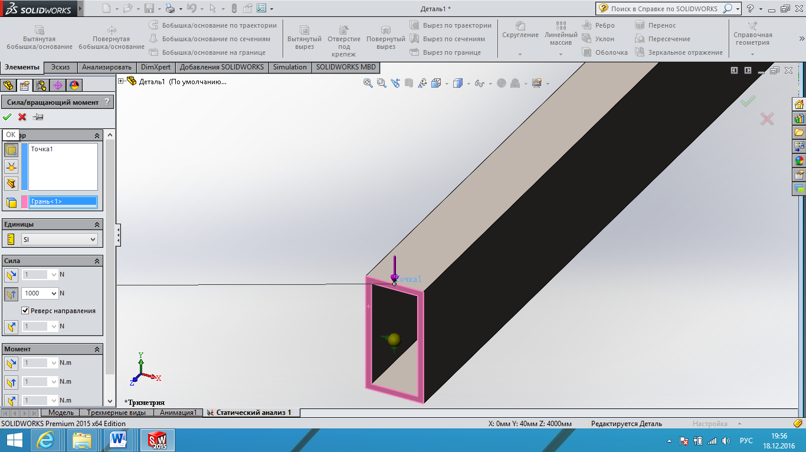

1. After that you apply moments in the same way:

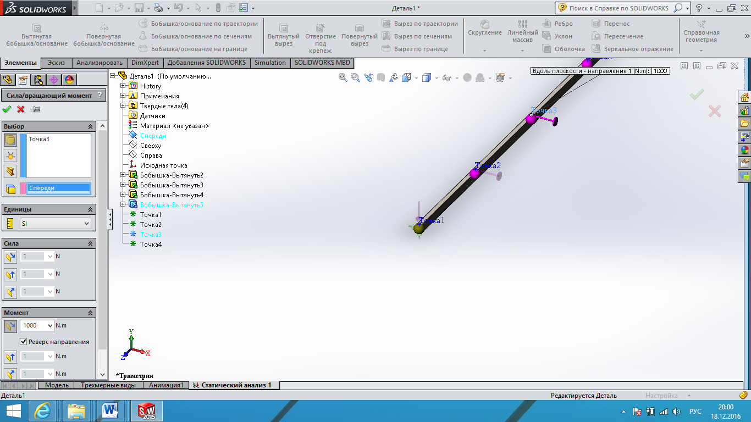

1. To apply distributed load you need to select by unit length button:

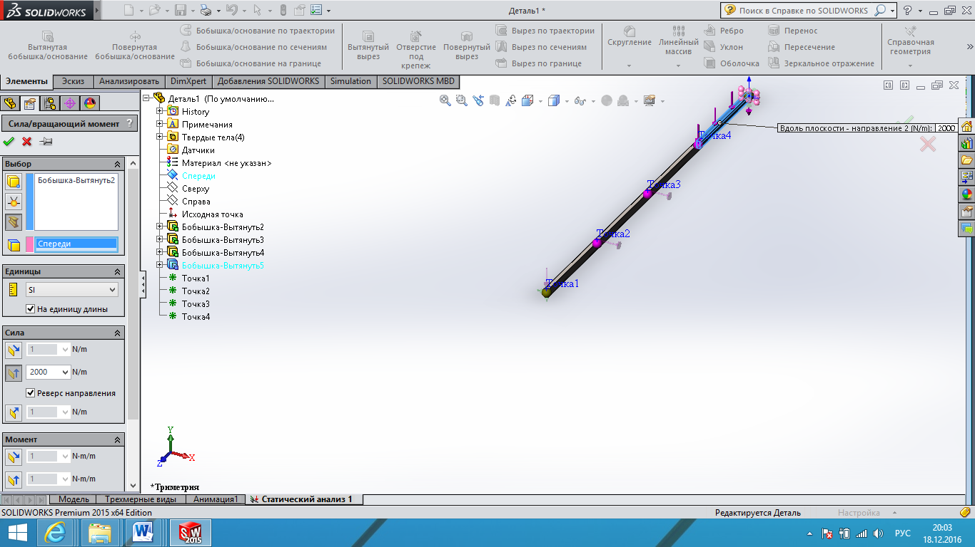

1. Then you need to generate the finite-element mesh.

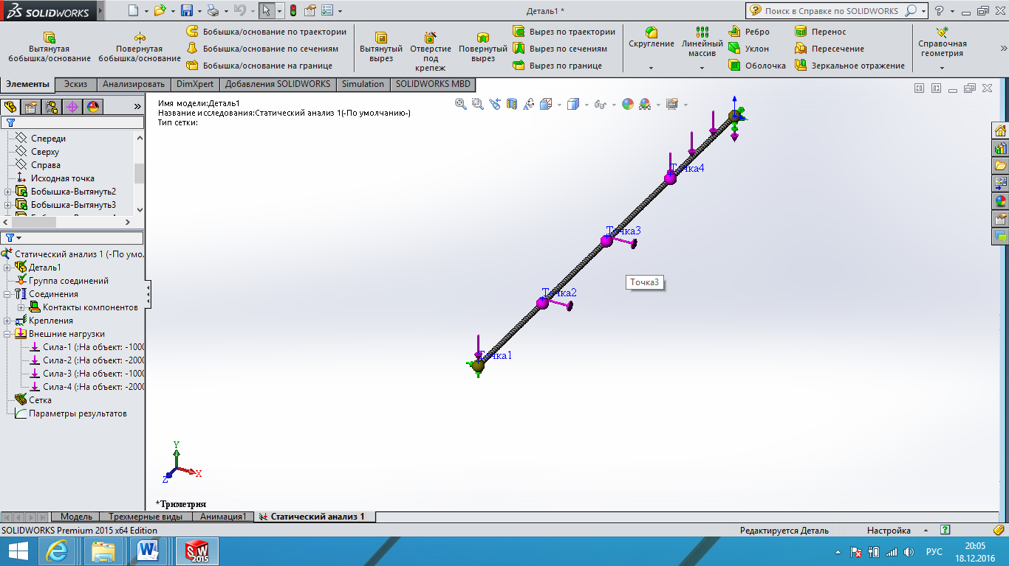

1. At last you need to launch the solution and observe results as follows. Some results are shown below.

*Deflections*

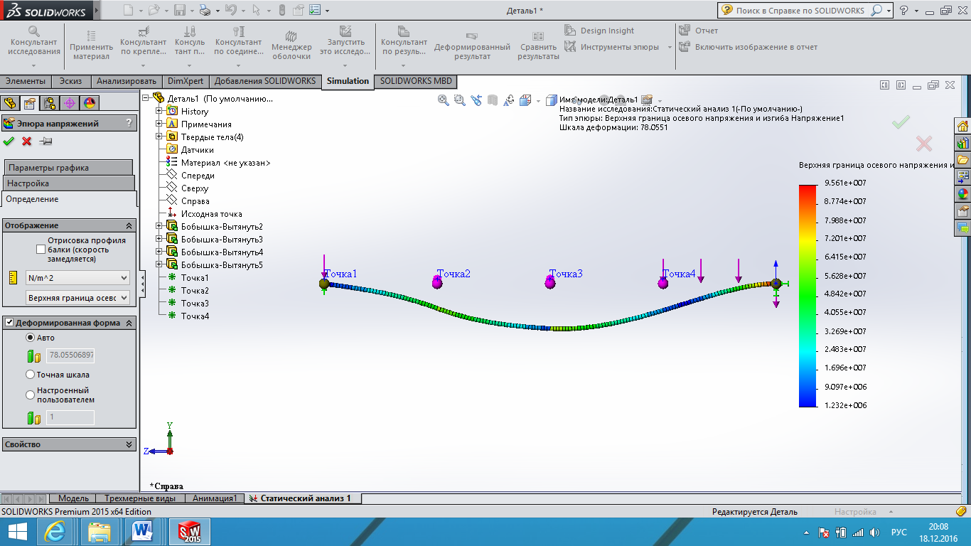

*Shear force diagram*

